Pre-trial detention, restrictions, and de facto solitary confinement
Forsete input to the Parallel report to the UN Committee Against Torture, September 2023.

General recommendations regarding Pre-trial detention (remand imprisonment)
- The Ministry of Justice should:
  - assess the causes of the historic and current overuse of pre-trial detention
  - develop concrete methods to lower the use of pre-trial detention
  - Bring an end to the extensive use of de facto solitary confinement.
  - Limit the extensive use of restrictions on visits and correspondence.
  - Implement measures so that pre-trial detainees are not discriminated compared to prisoners serving a sentence.

General facts about Pre-trial detention in Denmark
There has been a peculiar and remarkable overuse of pre-trial detention in Denmark which has gotten much worse in recent years when compared to most other European countries including the other Nordic countries.
Pre-trial detention in Denmark compared to the other Nordic countries:
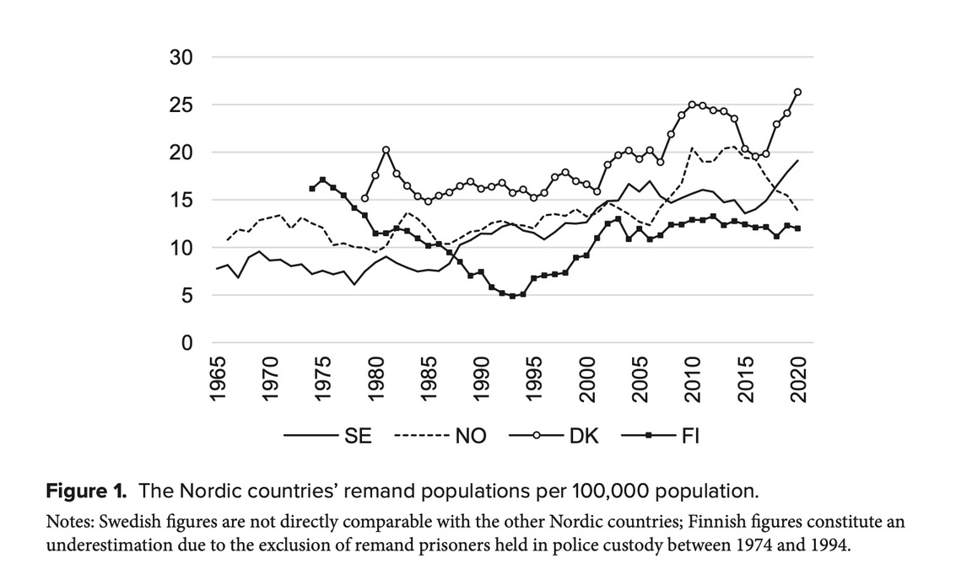

Number of pre-trial detainees (remand prisoners) in relation to the total number of prisoners in the Nordic countries in 2022 (percentages):
Denmark Sweden Norway Finland Iceland European median
41 28 23 22 18 21,7

Remarkably 60 % of time spent in pre-trial detention takes place after the police investigation has been concluded and charges have been made. Furthermore, processing time at the courts have risen dramatically in recent years. In criminal case the court processing has almost doubled from 4,4 months in 2018 to 8,4 months in 2022.
Despite this situation, the available alternatives to pre-trial detention are almost never used by the courts/prosecution. For example, surrogate detention according to Section 765 of the Administration of Justice Act is used almost exclusively for young people under the age of 18 and mentally deviant people over the age of 18. This practice seems not to meet the requirements of the Administration of Justice Act and the ECtHR's art.5, according to which detention should be considered as a last resort and only if the purpose cannot be achieved with less intrusive means.

Restrictions and de facto solitary confinement during pre-trial detention
The extensive use of pre-trial solitary confinement in Denmark (and the other Scandinavian countries) has been a long-standing issue where CAT and CPT has criticized Denmark and the other Scandinavian countries extensively over the years. On the surface, Danish authorities have responded successfully to these critique through legal changes and reforms that have brought the use of court ordered pre-trial solitary confinement down to a minimum (used in less than 1 % of all cases of pre-trial detention). However, in reality, a majority of pre-trial detainees are currently in de facto solitary confinement dure to lack of staff and often also to a lack of communal spaces in the old remand institutions.

The result is in other words remarkable and most unfortunate: after decades of debate and criticism Danish authorities finally acknowledged that the use of pre-trial solitary confinement is unhealthy, unjust, and dangerous and as a result almost abolished the use of court ordered pre-trial solitary confinement. Yet today, most pre-trial detainees in Denmark are still subjected to pre-trial solitary confinement. As a result, pre-trial detention has been labeled “Denmark’s harshest punishment” even though the detained individuals have not been sentenced yet.

In addition to the continuous use of isolation Denmark has a long-standing practice of restricting the correspondence and visits of pre-trial detainees - a measure labeled B&B. This creates a regime making it exceedingly difficult to maintain meaningful contact with family members and children, the latter which have a right to maintain contact with their parents when it is in the best interest of the child. Today more half of all placements in pre-trial detention have additional restrictions on correspondence and visits. Such measures are supposed to be based on specific individual circumstances, but practice indicate that they are applied more or less automatically without any individual argumentation or concerns.

This overuse is documented by the figures/tables presented here. See also CPT, Report to the Danish Government on the visit to Denmark by the CPT from 3 to 12 april 2019. CPT/inf (2019) 35, para. 29.
Remand populations are a function of the number of individuals imprisoned on remand and the length of remand placements, and then measured pr. 100.000 population. See Lönnqvist, E. (2023) Prisoners of process: The development of remand prisoner rates in the Nordic countries, Nordic Journal of Criminology, Vol.24, Iss.2.
https://menneskeret.dk/status/faengsler-frihedsberoevelse#toc-vores-vigtigste-anbefalinger¨.
Besvarelse af spørgsmål nr. 382 (Alm.del) fra Folketingets Retsudvalg, 3.4.2023, tabel 3.
https://domstol.dk/aktuelt/2023/3/fortsat-lange-sagsbehandlingstider-i-2022/
Kessing, P.V. (2023) Varetægtsfængsling og menneskeret, Ugeskrift for Retsvæsen, B/145.
Smith, P.S. (2006) The Effects of Solitary Confinement on Prison Inmates: A Brief History and Review of the Literature, Crime and Justice, Vol 34, no. 1.
Peter Scharff Smith and Janne Jakobsen (2027) Varetægtsfængsling- Danmarks hårdeste straf?, Jurist- og Økonomforbundets forlag.
2018: 58,0% correspondence restrictions and 67,9 % visit restrictions; 2020: 65,7%/65,6 %; 2022: 62,9%/62,8 %. https://menneskeret.dk/status/faengsler-frihedsberoevelse#toc-vores-vigtigste-anbefalinger

